
EASTERN INTERNATIONAL UNIVERSITY Week 8 Practice – Quarter 2, 2025-2026
SCHOOL OF COMPUTING Method: Create Neo4j example AND Course Name: Advanced Databases
INFORMATION TECHNOLOGY Course Code: CSW 436  Student’s Full Name:
Student ID:

Open Neo4j Browser: You can practice in two easy ways:

Option 1 (Recommended – Online)

Use Neo4j AuraDB
Steps:
- Go to: https://neo4j.com/cloud/aura/
- Create a free account
- Create a Free Instance
- Click Open with Neo4j Browser
- You will see a query editor

Option 2 (Install on your Computer)
Download Neo4j Desktop Steps:
- Download from https://neo4j.com/download/
- Install the software
- Create a new project
- Create a local database
- Click Start Database
- Open Neo4j Browser

Run the Practice Queries
In the query box, write and run queries one by one.

- Create three Person nodes in Neo4j with the following properties. Write a Cypher query to create these nodes in Neo4j.
Name | Age
Alice | 22
Bob | 25
Charlie | 23
CREATE (alice:Person {Name: 'Alice', Age: 22})
CREATE (bob:Person {Name: 'Bob', Age: 25})
CREATE (charlie:Person {Name: 'Charlie', Age: 23})
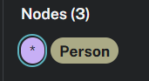
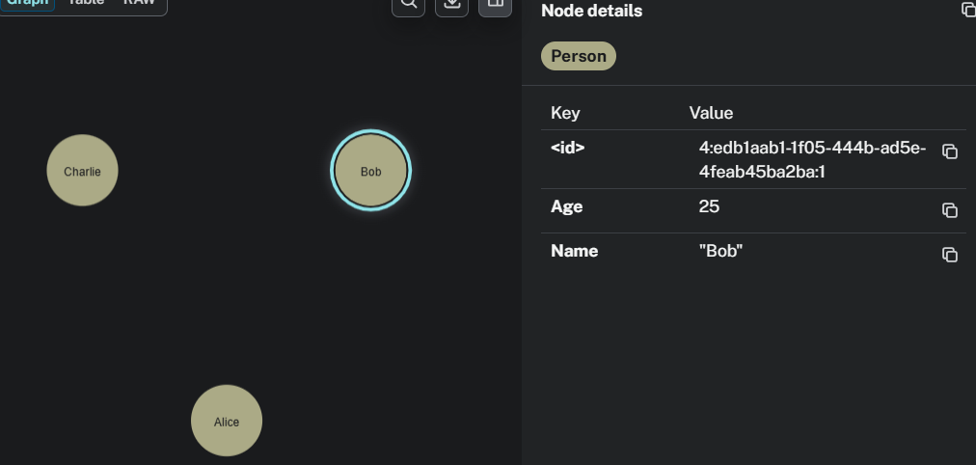

- Create Relationships using the nodes created above and write a cypher query to create these relationships.
  - Alice is FRIEND_OF Bob
  - Bob is FRIEND_OF Charlie
MATCH (alice:Person {Name: 'Alice'})
MATCH (bob:Person {Name: 'Bob'})
MATCH (charlie:Person {Name: 'Charlie'})
CREATE (alice)-[:FRIEND_OF]->(bob)
CREATE (bob)-[:FRIEND_OF]->(charlie)
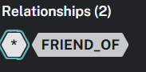
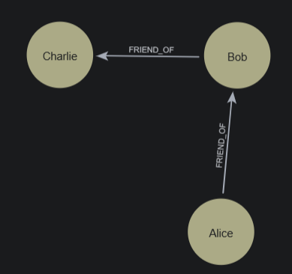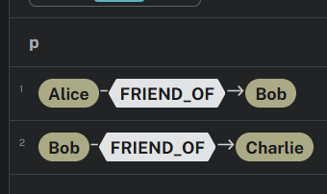

- Write a query to display all Person nodes stored in the database.
MATCH (p:Person)
RETURN p
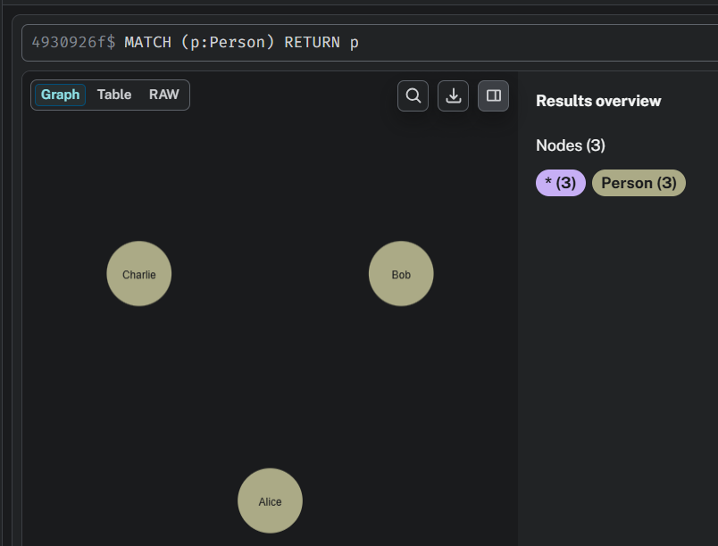
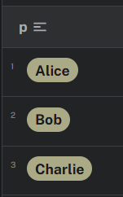

- Write a query to find all friends of Alice.
MATCH (alice:Person {Name: 'Alice'})-[:FRIEND_OF]->(friend)
RETURN friend
